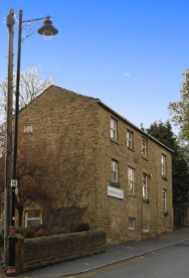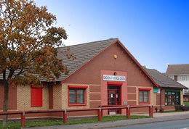

OUT OF AREA REGISTRATIONS

I _____________________________________________accept that I have registered at Grove House Surgery/Chickenley Medical Centre despite living outside the area.

I am regularly in the area because__________________________________ and if my circumstances change I will inform the practice

If I have any medical conditions that require complex input from a local service, I understand that I will be informed and my out of area registration will not be accepted and I will register with a GP nearer to my home.

I accept that this registration does not provide me with home visits from my GP, 111 services and local out of hour’s providers in my home area will provide these.

Name_____________________________________________________

Date of Birth___________________________________________________

Signature_____________________________________________________

Date_______________________________________

